printing of a human skeleton

Sokolnice elementary school
Masarykova 20, Sokolnice 664 52

Contents:
Printing of a human skeleton 3
Equipment for creating a human skeleton 3
Workflow 4
Human skull 5
Spine model 9
Model of the female pelvis 11
Human pelvis model 2 11
Foot Model 12
Hand model (palm) 12
Femur Model 13
Model of tibia and fibula 14
Upper limb model 14

Printing of a human skeleton

Equipment for creating a human skeleton

The following equipment is required to 3D print a human skeleton:
- 3D printer (https://www.prusa3d.com/cs/produkt/stavebnice-3d-tiskarny-original-prusa-i3-mk3s-3/)
- 3D scanner (https://www.vyuka-vzdelavani.cz/3d-tisk/matter-and-form-v2-3d-skener.html#2905)
- Filaments (https://www.prusa3d.com/cs/produkt/pla-extrafill-metallic-grey-750g/)
- Processing tools (https://www.datart.cz/mini-bruska-extol-craft-404111-130-w.html?gclid=CjwKCAiAzrWOBhBjEiwAq85QZ05XJrzB0v64dGQ_l3n9Ei1bxcuZS4R5fMU9cgXOJaptGArwhXa-FRoC0osQAvD_BwE, https://www.alza.cz/hobby/krt452002-modelarske-noziky-sada-36ks-d6774988.htm?kampan=adwho_hobby-a-zahrada_pla_all_hobby-a-zahrada-css_rucni-naradi_c_1003737___409276959993_~89341522482~&gclid=CjwKCAiAzrWOBhBjEiwAq85QZ0BmWYBwC4tGAUiFnM430FnaCzNE05PFUfx6V3j695ICxckLdYJilBoChkMQAvD_BwE, https://profimodel.cz/cs/celistove/250036-modelcraft-mini-kleste-v-pouzdru-sada-5060030667470.html?gclid=CjwKCAiAzrWOBhBjEiwAq85QZ7KT_pvdWv0GqDiNe1H6SR7OyS9c9P9Sb2ZiRu7scRsFrh8pn_GSzhoCCs0QAvD_BwE#250036k#250036kD)
- Magnets (http://www.neomag.cz/cz/katalog/neodymove-magnety/valce/magnet-nv0065-3x1-5-n42/?from_katalog=1,razeni, http://www.neomag.cz/cz/katalog/neodymove-magnety/valce/magnet-nv340-6x3-n38/?from_katalog=2,razeni,)
- Glue (https://www.lepidla-online.cz/eshop/p/loctite-406-20-g-vterinove-lepidlo-50/?gclid=CjwKCAiAzrWOBhBjEiwAq85QZ3OMy5ght9I6NnVPTUZKbwQT5bwyax2SrDhh03mD6kkrL6vuU20Z4BoCcq8QAvD_BwE)

Workflow

To create a 3D model of the human skeleton in life size, we used freely available models of individual parts of the skeleton from the internet, which we adjusted to the appropriate size of the model in the PrusaSlicer program. We scanedf those parts of the skeleton for which we could not find a freely available model using a 3D scanner (e.g. human ribs). All parts of the frame need to be thoroughly processed or connected (glue, magnets, wires...).

Human skull
available free model available at: https://www.thingiverse.com/thing:4830026?fbclid=IwAR1THNG8fDaSkhpWNWe4OqMETV_nY49tXryAA2aL6W4fAW_TF1LfOZcyUss
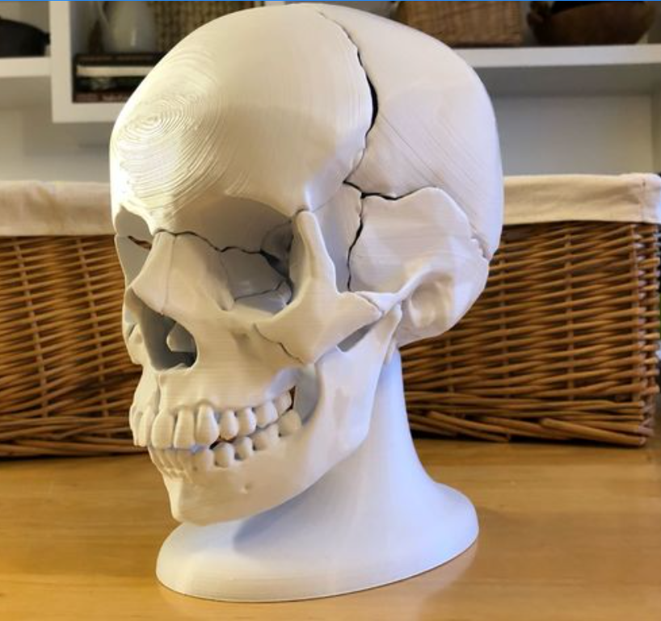

The skull consists of 18 parts.

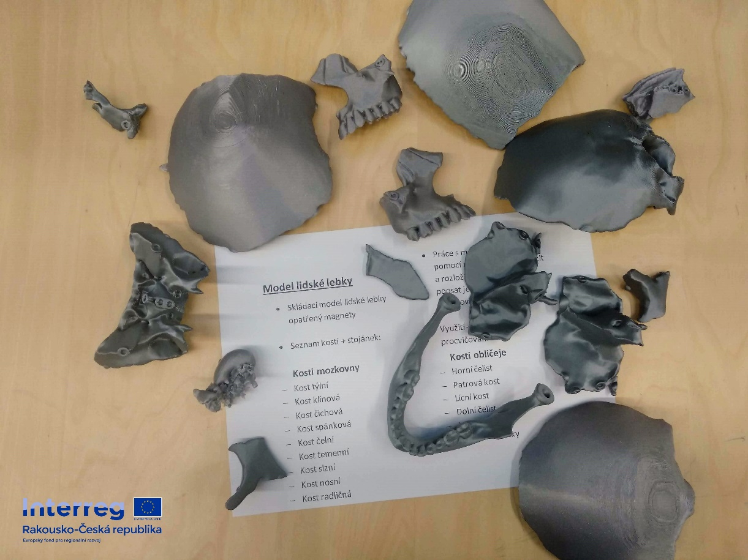
Each part needs to be processed.
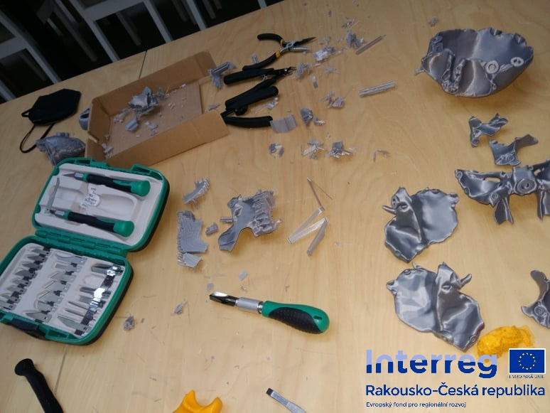
It is necessary to stick the magnets correctly in each part.

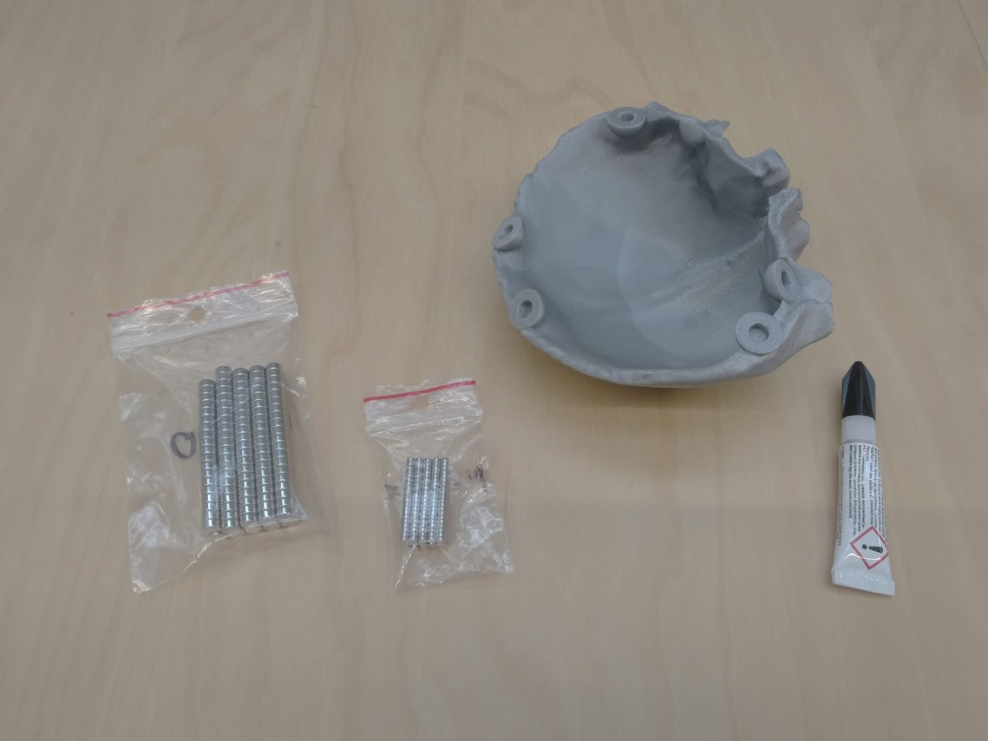

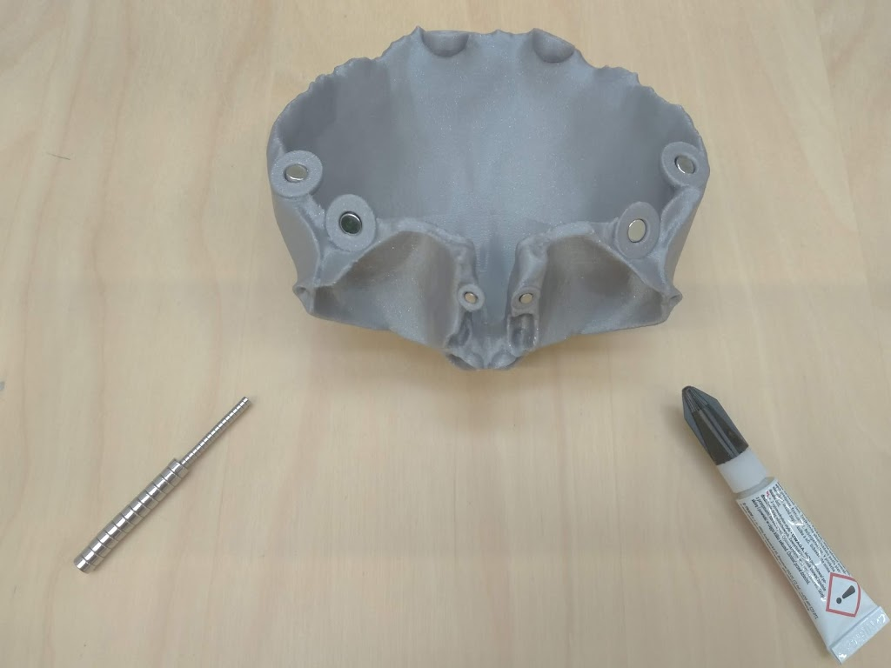

spine model
the model, like all others, needs to be scaled to match the other parts. We followed the skeleton model that we already have at school.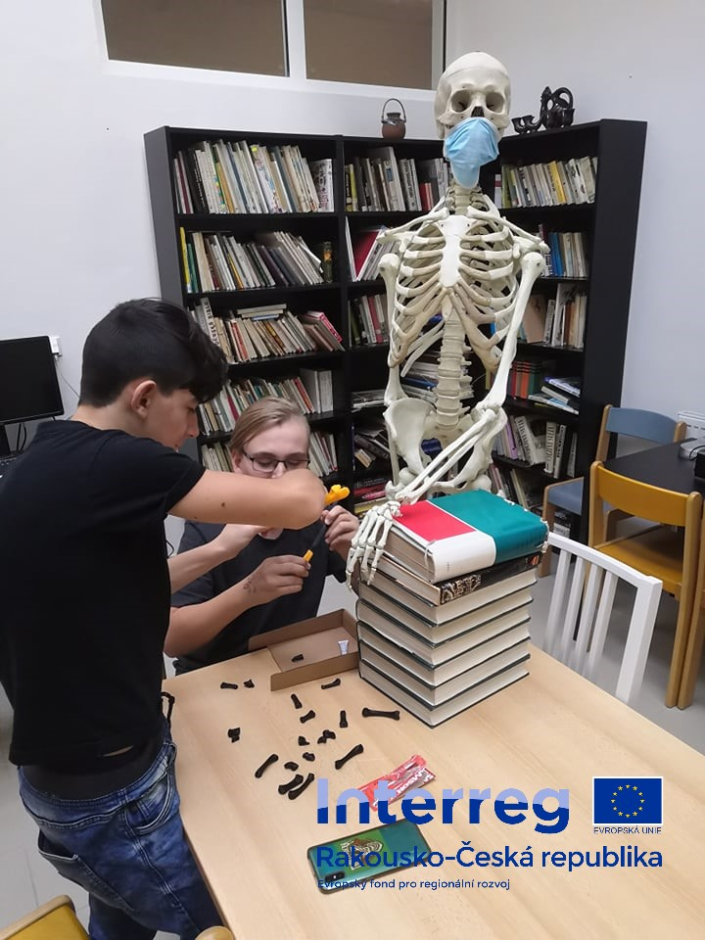
And here is the link to the spine model - https://www.thingiverse.com/thing:4982223
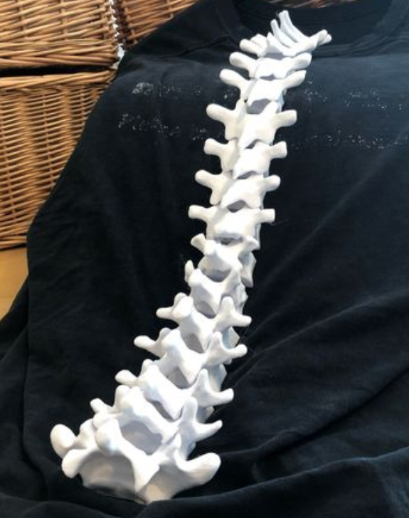

Model of the female pelvis – once again, it can be disassembled thanks to magnets. The link is here https://www.thingiverse.com/thing:4946668
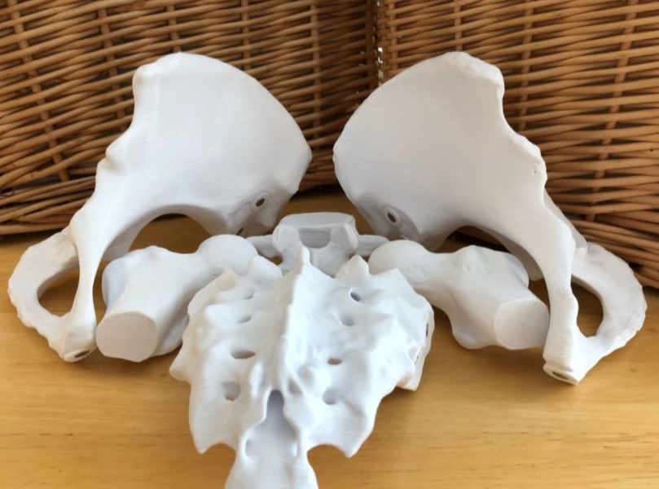
Human pelvis model 2 - https://www.thingiverse.com/thing:4937177
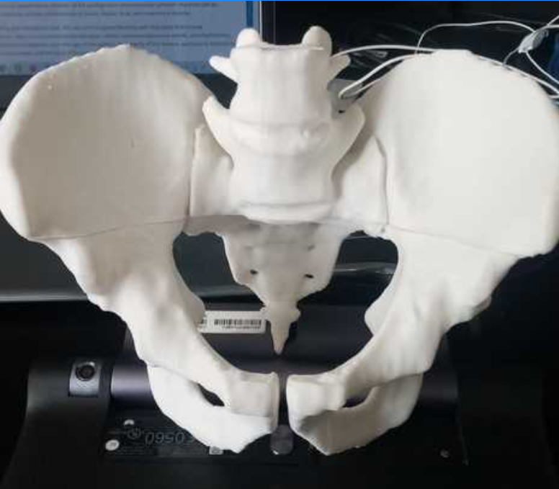

Foot Model– link: https://www.thingiverse.com/thing:4849504
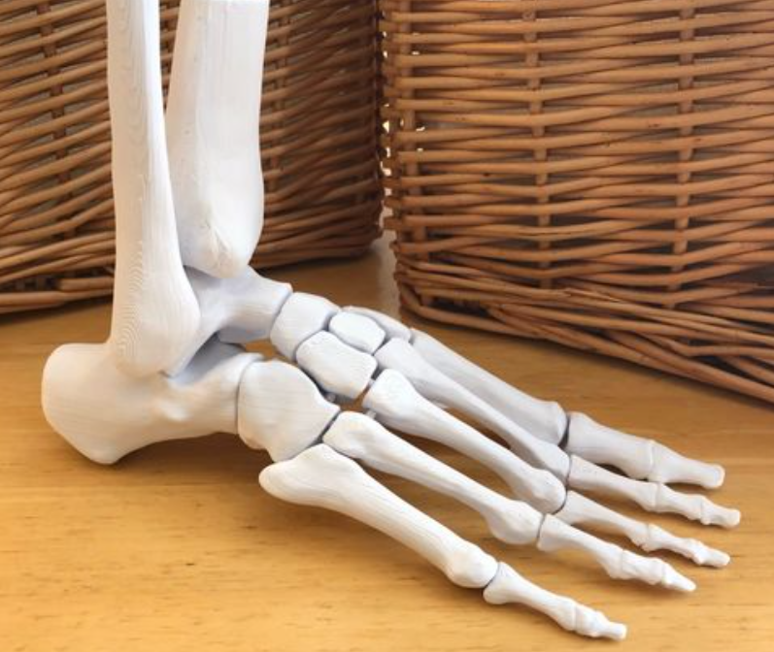
Hand model (palm) – link: https://www.thingiverse.com/thing:4841107
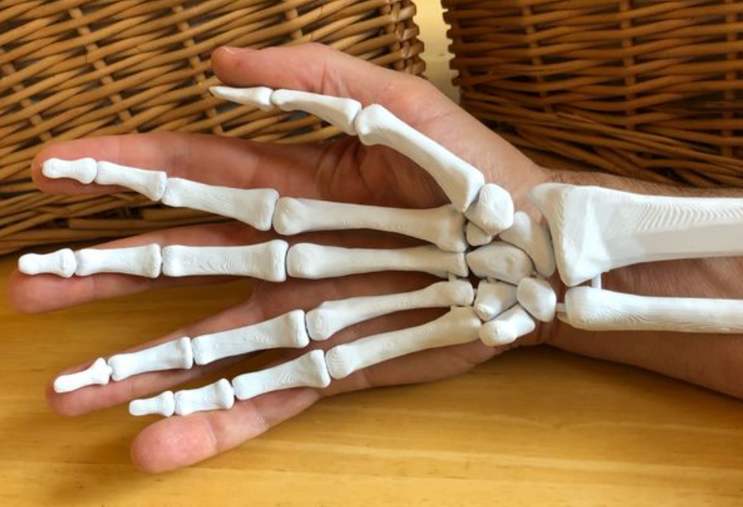

Femur Model- https://www.thingiverse.com/thing:5820, https://www.thingiverse.com/thing:3295652
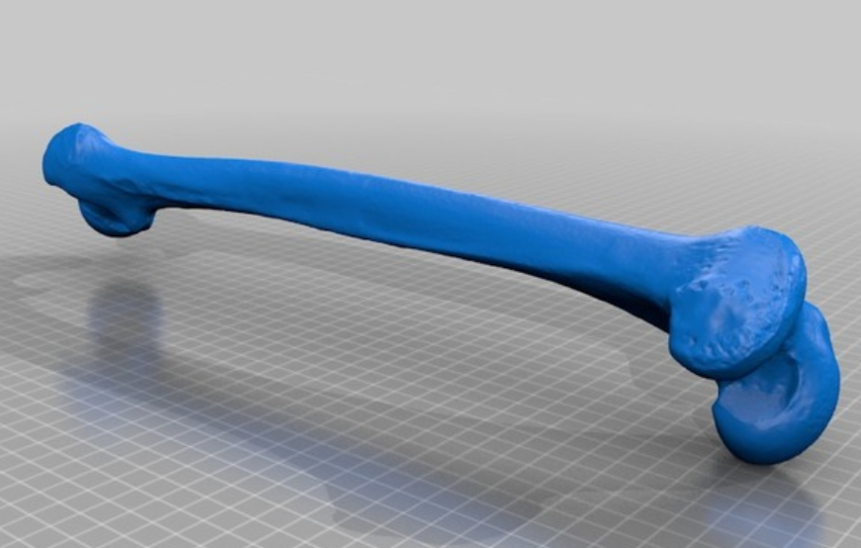
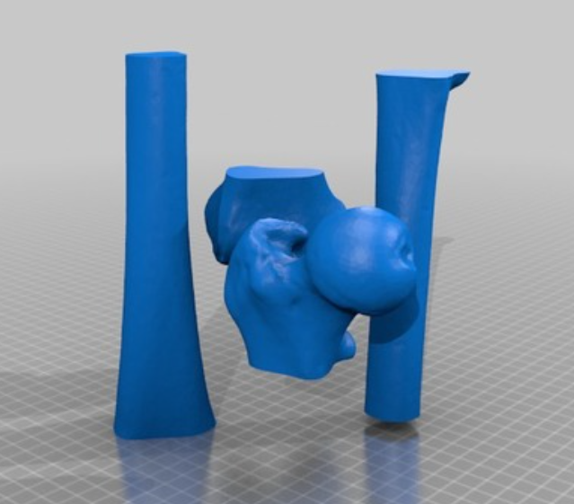
Model of tibia and fibula- https://www.thingiverse.com/thing:1030467
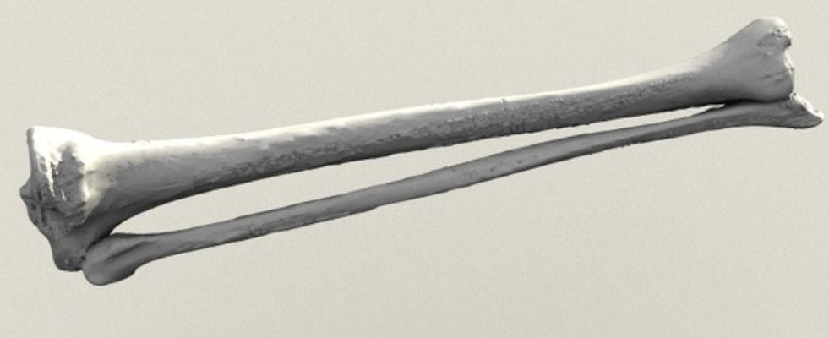
Upper limb model- https://www.thingiverse.com/thing:1352085
